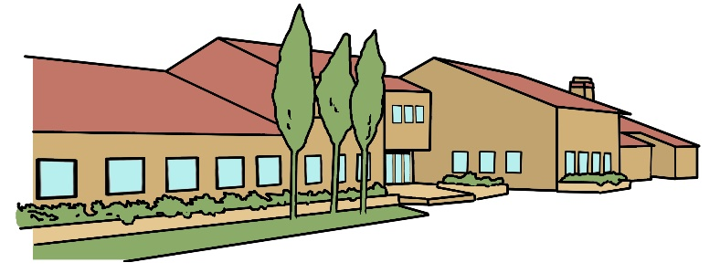
Bradwell Village School
Year Six Newsletter
September 2023

Curriculum Overview
English
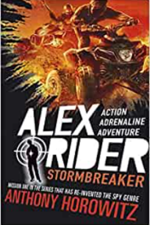
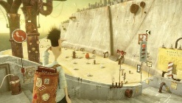
We will be looking at a variety of text types and creating links with our foundation subject. This term we will be working on writing our own descriptions based on a beach setting from the text: The Lost Thing. This will be great preparation for our work with writing a short fantasy story later in the term. Linked to our History and Geography work, we will write a diary entry using an extract from the Diary of an Edo Princess, which we will use for our Guided Reading work after Anthony Horowitz’s Storm Breaker. A very exciting read! Throughout the term, we will also be focusing on the basics of spelling, punctuation and grammar.
Maths
This term we will be looking at place value and number operations, relating these to real life problems. We will spend a lot of time focusing on our written and mental methods and will be utilising these for worded problems. Our Back to Basics sessions will continue to develop the speed of mental recall, particularly when it comes to times tables.
Science
We will be studying the evolution and their inheritance to find out more about how living things on Earth have changed over time. We will look at how characteristics are passed from parents to their offspring and how variation over time affects survival in particular environments.
Computing
In Computing we will be refining our research skills as well as studying how to be safe online.
Games/PE
In Games & PE we will be developing our invasion games through football, netball and basketball as well as gymnastics.

French
The children will be learning to talk about and write about how they can look after the planet and learn the vocabulary linked to the environment.

RE/PSHE
In RE we will be learning about why, where and how people worship. In PSHE we will be discussing behaviour choices, the year ahead and fears and worries of the future. We will also be promoting the values of Kindness & Respect.

History
In History, we will be learning about the ancient civilisation of the Kingdom of Benin.
Geography
We will be learning about settlements and carrying out a local study comparing Milton Keynes to Benin
Design & Technology
We will be using textiles where we will combine different fabric shapes and other elements.
Art
We will be studying and making masks and costumes in the style used in Western Africa.
Music
We will learn about musical vocabulary and their meanings to be able to use them in musical appraisals. We will also learn the lyrics to sing songs, and compose and play instruments to a melody using simple rhythms.
Homework
Maths and English homework will be set every week. Open ended tasks are optional on the homework overview for the term. Please encourage your child to complete all homework to the best of their ability.
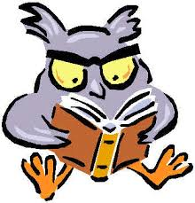
Reading
We ask that the children read on a daily basis. Please encourage your child to read a variety of texts: fiction, non-fiction, paperbacks, hardbacks, the classics, newspapers, comics, magazines etc.
Spellings
Spellings are taught weekly. The children are given a list of words each week that fit the spelling pattern that they are working on. These words need to be practised at home for their weekly assessment.
Times Tables
The children need to know, and be able to quickly recall, their times tables and all related facts. Any practice at home will be a great advantage. You can use Times Tables Rock Stars to do this.

Year 6 Teaching Staff
Mr Yearsley (Class Teacher 6AY) Mrs Sheldon (Class teacher 6TS)

Learning Support Assistants Mrs Crew and Mrs Addo

Contact Us
If you need to contact your child’s class teacher, we are always available at the gate after school. Alternatively, you can email us directly on our class email addresses.

We look forward to a wonderful term of hard work, challenge and celebrating success.

