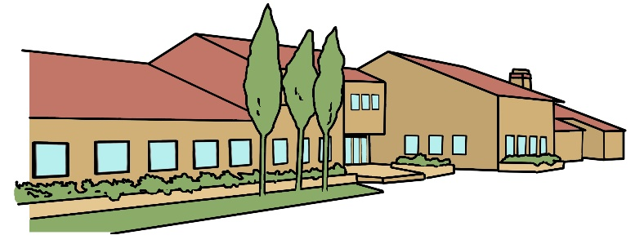
Bradwell Village School
Year Five Newsletter
September 2023

Subject Overviews
English
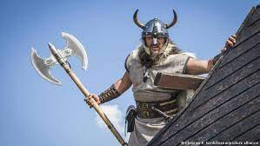
With links to our History curriculum, we will be writing a setting description on a Viking battlefield, a character description on a viking and a story based on our reading of the tale ‘Beowulf’.

Maths
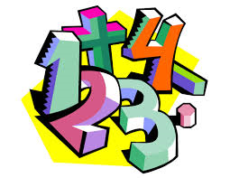
This term we will be learning and reinforcing the number system. We will look at consolidating the understanding of the written methods for the four operations, place value and recognising the relationships and patterns that exist between numbers. We will have regular logic and problem solving sessions and regular B2B sessions that will focus upon mental methods and speed of recall for multiplications.

Science
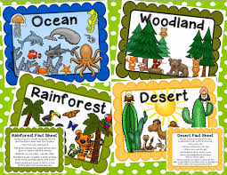
We will be learning about living things and their habitats. We will learn about the life processes of living things and their life cycles and about reproduction in specific plants and animals. We will also learn about the properties and changes of materials and we will be able to identify and compare everyday materials and understand dissolving. We will be able to separate different mixtures and identify reversible and irreversible changes.

Computing
We will be learning and developing our coding skills and creating presentations to show our understanding.

Games/PE
We will developing the skills to play and compete in a variety of Invasion Games. We will be learning how to attack and defend, find space and how to work collaboratively as a team to succeed in order to shoot and score goals.

Music
In music we will learn about the importance Viking songs held for their people and we will learn and perform some of them. Additionally, we will compose our own songs. We also use and follow ‘Charanga’ and the children will learn about a variety of songs.

French
French will be taught through a variety of games, songs and spoken activities. The children will be learning how to order food and drink in a café and the names of parts of the body of animals.

RE/PSHE
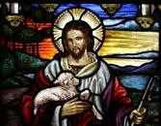
In RE we will be learning about Christianity – Journeys and Practices.
In PSHE we will be learning about balancing lifestyles, working co-operatively and how we can resolve conflicts that arise. We will also be developing our understanding of well-being and our Autumn Term school values of Kindness & Respect.

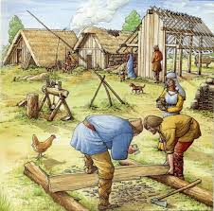
History
In History, we will understand the reasons why people settle in different places and why the Romans left Britain and subsequently the Scots, Anglo Saxons and Vikings invaded. We will look at archaeological evidence and be able to draw inferences from it. We will learn about the art and culture of this period and learn about significant Anglo Saxon and Viking leaders.

Geography
In Geography, we will investigate Anglo Saxon place names and see which exist to this day. We will continue to develop our knowledge of identifying major countries and cities on a map or globe and improve our map reading skills and our use of an atlas.

Art
In Art we will be finding out about Viking long ships, particularly looking at prow heads. We will be working on improving our shading techniques.

DT
We will be investigating frame structures and how to make a structure strong. We will make a frame structure for a Saxon settlement.
Year 5 Teaching Staff
Mrs Cleere (Upper Key Stage 2 Lead and Class Teacher 5SC) and Miss Vivian (Class teacher on 5LJV)

Learning Support Assistants Miss Allan and Mrs Bardsley.

Contact Us
If you need to contact your child’s class teacher, we are always available at the gate after school. Alternatively, you can email us directly on our class email addresses.
5SC@bvs.ilf.education
5LJV@bvs.ilf.education

We look forward to a wonderful term of hard work, challenge and celebrating success.

