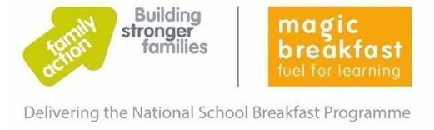
We are delighted to inform you that Bradwell Village School has joined the government's National School Breakfast Programme (NSBP), which is being delivered by the charities Family Action and Magic Breakfast.
As a NSBP School we are pleased to be able to offer a healthy school breakfast, available to all, and enjoy the benefits that brings, with children settled and ready to learn at the start of the school day. The programme runs until July 2024 and provides support to schools to enable them to operate the scheme.
We will be offering children half a bagel as they arrive at their classroom each morning (8.50am). This scheme is offered to all children and is completely separate from our current Breakfast Club which will continue to operate as normal.
We have attached the ingredients of the bagels for allergy information and ask that you let the school office know if you do not wish your child to partake in the scheme. We will not be serving any cereals as showing in the allergy list. The children can choose if they wish to take part and we will be offering fruit for those children who have gluten intolerance.
Our first order for the bagels has been made, however we have not yet been given an exact delivery date. Therefore, we are hoping the scheme will commence as soon as possible. Please complete the form below should you wish your child to take part. Bagels will not be given without a completed form.

Please contact the school office if you have any queries regarding the scheme.

Kind Regards

Mrs N Okell
Bradwell Village School

Name of child ___________________________________ Class_____________________

I wish my child to have a daily bagel

My child has a gluten allergy and would like fruit

