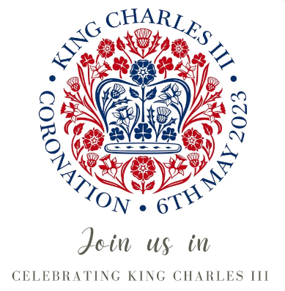

Dear Parents/Carers,

You are cordially invited to join us in our celebrations for the historic occasion of the coronation of King Charles III on Friday, May 5th. Parents/carers are welcome into school from 2pm to participate in coronation activities and afternoon tea with your child(ren).

We will be providing scones but would also be grateful for donations of other shop bought, nut free cakes. We would be grateful if donations could be brought into school by Wednesday, May 3rd. Tea, coffee and drinks will also be available during the afternoon.

Children can come into school on Friday, May 5th in clothes of red, white and/or blue.

We hope you can join us and look forward to seeing you on this momentous day.

