Welcome to the first edition of the BVS Wellbeing Newsletter. We will publish a newsletter every half term. It will be packed full of wellbeing facts and handy hints.

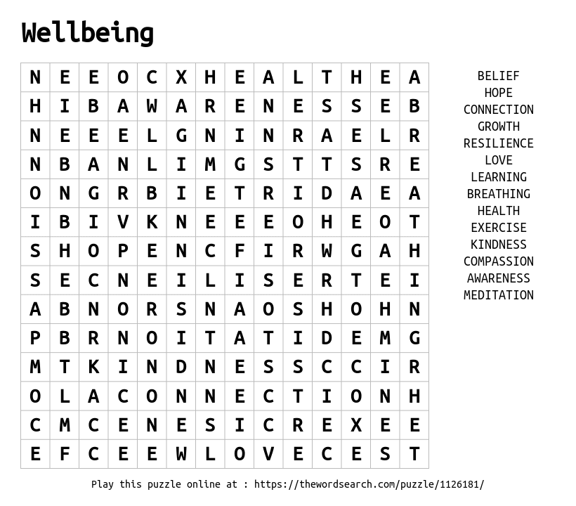
Why was the bird in the library?
He was looking for bookworms.
This newsletter was brought to you by the Bradwell Village School Wellbeing Ambassador Group. November 2023
Keep me or recycle me.
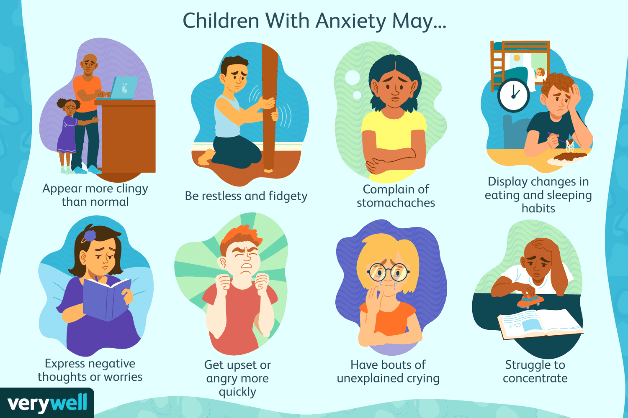
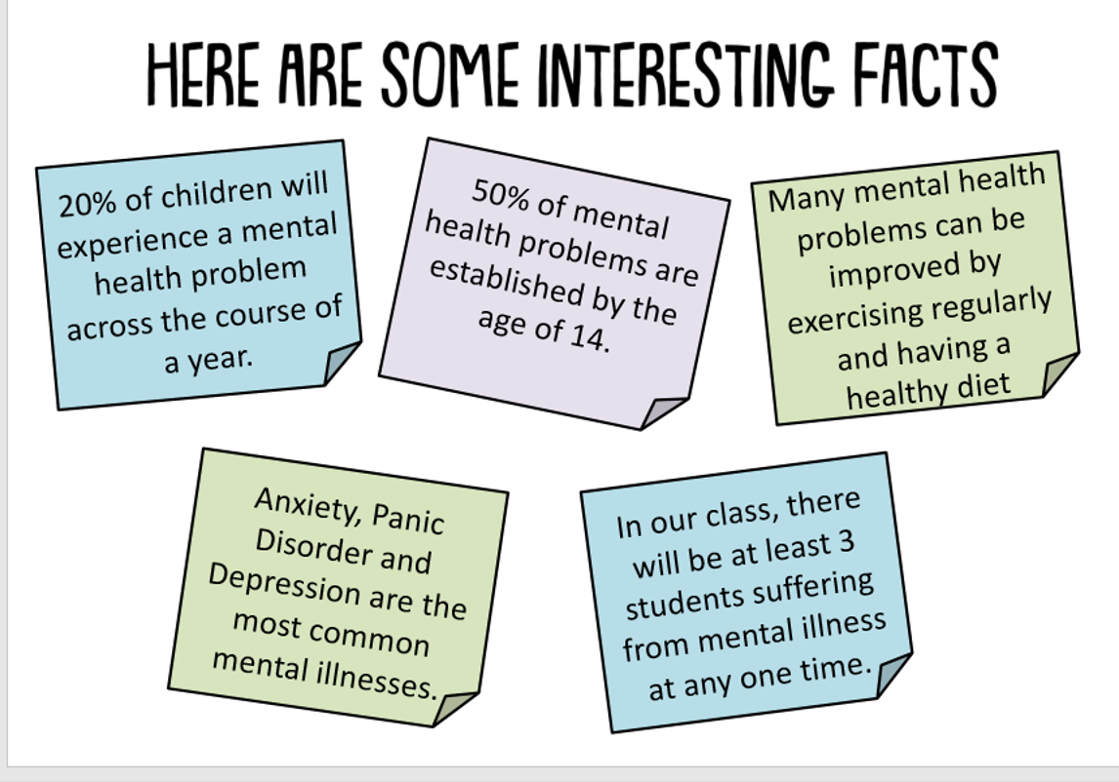
How to stay mentally and physically healthy in the holidays.
- Take time to think
- Spend time in nature
- Drink lots of water
- Smile
- Have good sleep
- Eat healthily

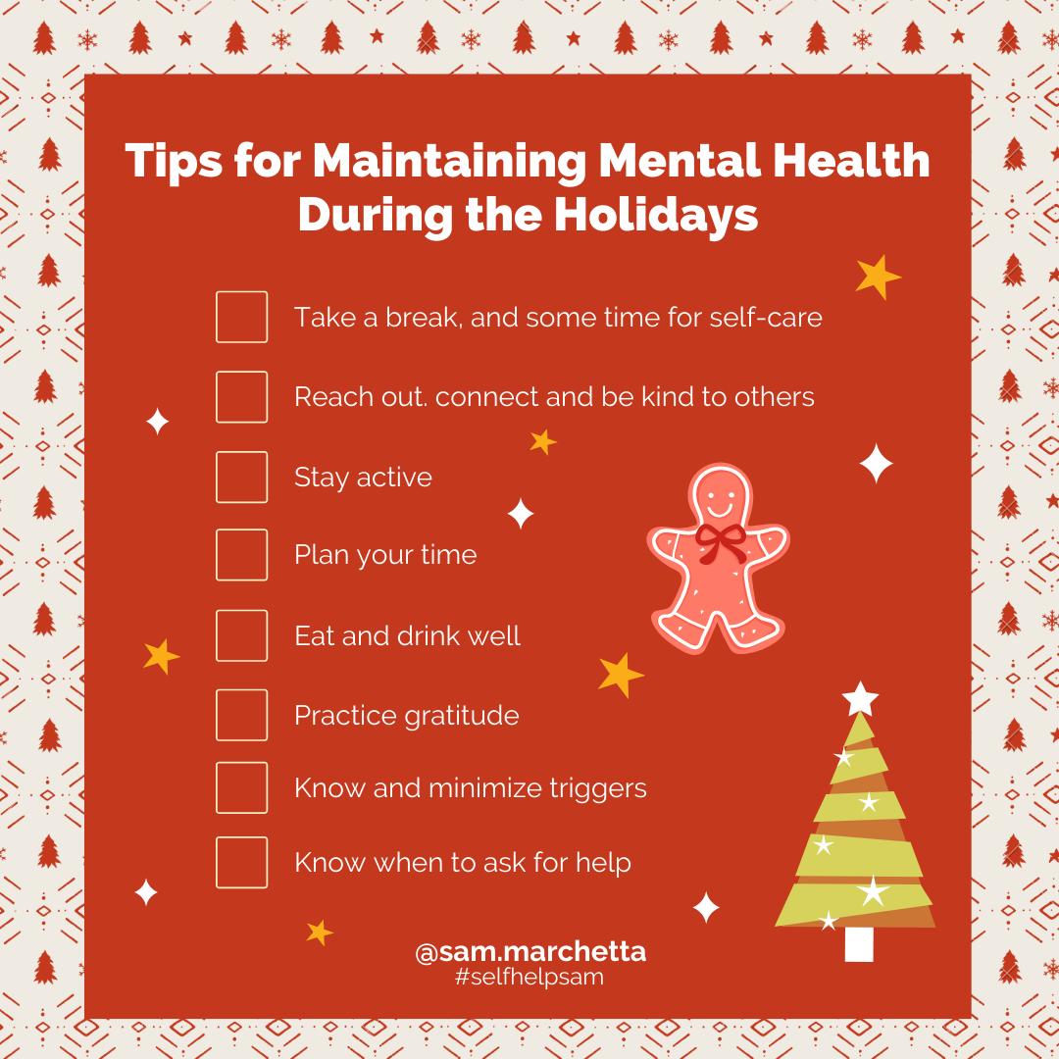
BVS Wellbeing News

