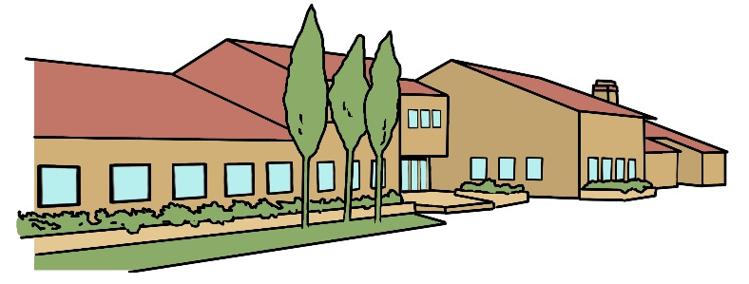
Bradwell Village School
Year Three Newsletter
January 2024

Subject Overviews
Dear Parent/Carer
The first term has flown by, and we are now welcoming in the Spring Term and a new year! We are kicking off the New Year with a Personal Development Fortnight based around Design Technology. If you have the time, please pop in on Friday 19th January, at 2.15pm, to see what we have been learning. We look forward to meeting you on our Parents’ Consultation Evenings, which will be Wednesday 6th March from 3.30-7.00pm & Thursday 7th March from 3.30-6.00pm, but if any issues arise in the meantime, please don’t hesitate to contact us.

English
During this term, we will be reading and performing some of Aesop’s fables, writing our own fable and playscripts. We will also write our own information page about the Ancient Greeks. We will continue to reinforce the basics of grammar and sentence structure and have weekly spelling tests. We will also continue to have our weekly Guided Reading sessions where we focus on the skills needed to answer comprehension questions, look deeper into the text and make inferences and deductions as well as develop our fluency, expression and deepen our enjoyment of reading.
Maths

This term we will continue to develop written methods for the main operations and use these methods to solve word problems. We will also be focusing on the children’s understanding of relationships between numbers and number facts. Through practical sessions we will investigate time, shape and measure. We will use our Back to Basics sessions to continue to develop rapid mental recall of number bonds and times tables through games and practical activities.
Science
We will be learning about forces and magnets. We will find out about forces between objects and whether magnetic forces can act at a distance. We will investigate, identify and group materials that are magnetic and learn about magnetic poles. We will find out whether magnets attract or repel each other.
Computing
In Computing we will develop our skills to create simple animations to make objects perform actions in a sequence. We will begin to write our own code and program a simple sequencing game.


History
In History we will be finding out about the Greek city states of Athens and Sparta and exploring their political systems and lifestyles, as well as learning about the Persian Wars and the impact they had on Greece. We will investigate the origins of the Olympic Games. We will research Alexander the Great and learn about the people and culture of Ancient Greece through archaeological evidence.
Geography
In Geography, we will use maps and atlases to locate Ancient and Modern Greece. We will be identifying the main features of the landscape in Greece and learn about its climate.
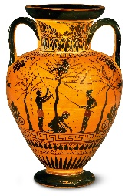
Art
We will explore a range of Greek art and use it to inspire us to design, make and evaluate our own Greek pot.
Design Technology
In DT we will design and make packaging using computer aided design.
Games/PE
In Games & PE we will learn the skills needed to play different net and wall games as well as invasion games like handball or basketball. We will also learn and perform some dance routines. PE kit is needed on Monday and Wednesday.
Music
In Music we will continue to use Charanga to listen and appraise a range of songs. We will reinforce our understanding of pulse, rhythm and pitch.
RE/PSHE
In RE we will continue to learn about the religion of Christianity and finding out how Christians are influenced and inspired by Jesus. We will also learn about the rules, codes and traditions that Christians believe they should live by.
In PSHE we will be discussing how to get on with others and resolve differences of opinion. We will investigate self-esteem and things that we are good at. We shall continue to promote our values.
French
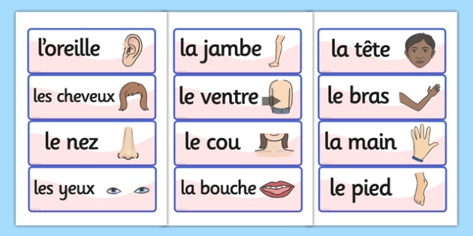
French will be taught by Miss Wiseman through a variety of games, books and songs. We will learn how to count to 40. We will also be taught how to name different parts of the body, including the face and descriptions of monsters. We will reinforce the words for colours.

