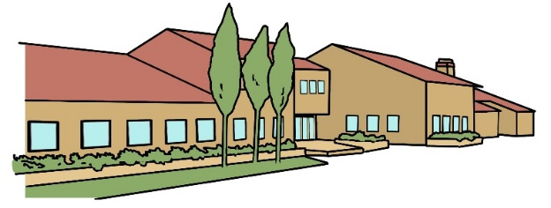
Year Five Newsletter
Spring 2024

Subject Overviews
Dear Parent/Carer
The first term has flown by, and we are now welcoming in the Spring Term and a new year! We are kicking off the New Year with a Personal Development Fortnight based around Design Technology. If you have the time, please pop in on Friday 19th January, at 2.15pm, to see what we have been learning. We look forward to meeting you on our Parents’ Consultation Evenings, which will be Wednesday 6th March from 3.30-7.00pm & Thursday 7th March from 3.30-6.00pm, but if any issues arise in the meantime, please don’t hesitate to contact us.
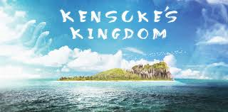
English
We will be reading the novel Kensuke’s Kingdom by Michael Morpurgo and writing narratives and newspaper articles inspired by it. In addition, we will continue to focus on the basics of spelling, punctuation and grammar.

Mathematics
This term we will be continuing to work on number, fractions, measures and statistics and we will be applying our knowledge to solve worded problems. Our Back to Basics sessions will continue to develop the children’s rapid mental recall of number bonds and times tables through games and practical activities. Please encourage your child to keep learning their Times Tables, they can do this by logging on to TTRockstars.

Science
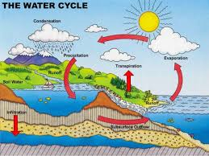
We will be learning where water comes from and how it is used to create power. We will record how weather changes over time and understand how rivers provide habitats for wildlife. We will be investigating earth and space and learning that the earth spins on its axis and how we have night and day. We will understand the relationship between the earth and the moon and why the sun appears to move across the sky. We will also compare other planet’s relationships with the sun.

Computing
We will be continuing to develop our skills of coding and also using ICT within our topic lessons for presentations.

Games and PE

In Games and PE, we will be developing our badminton skills and further working on the skills and strategies needed for playing sports such as tag rugby and basketball.

PE Kits – Tuesday and Thursday

French
The children will learn the names of different buildings and places within a town. They will begin to write about places they can visit. In the second half of the term they will recap parts of the body and learn how to have a conversation about medical emergencies.


RE/PSHE
In RE we will be learning about the religion of Islam. In PSHE, our first unit is called ‘Dreams and Goals’ where we will be looking at our aspirations for jobs and careers in the future. Our second unit is called ‘Healthy Me’ where we will be learning about the effects of legal and illegal drugs as well as looking at body image and first aid.

In History we will be continuing with our topic on the Vikings as well as comparing the uses of rivers today to those in the past.

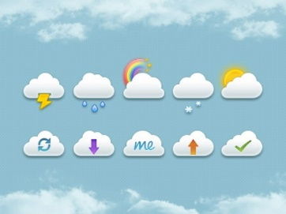
In Geography we will be learning about the water cycle, how clouds are formed and features of rivers, mountains and coasts. We will be identifying UK Rivers. We will be thinking about the advantages and disadvantages of flooding and how the lower river changes the landscapes. We will be comparing extreme weathers and understanding about climates around the world.

In Art we will examine how artists have interpreted weather and how they have used rivers and water in their work. We will be creating work inspired by the artists we study.

In Design and Technology, we will continue to build our frame structures as well as looking at food from different cultures and creating and following a recipe.

In Music we are learning to listen and appreciate different genres of music and will be learning to play an instrument.

