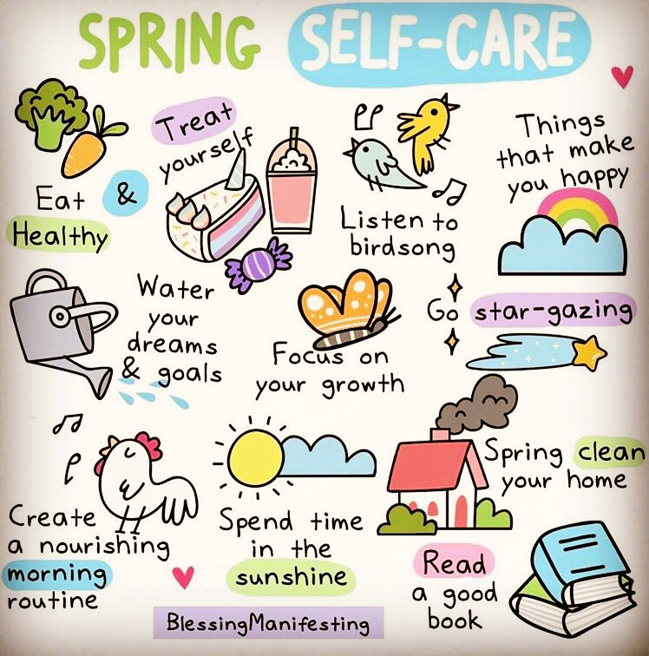
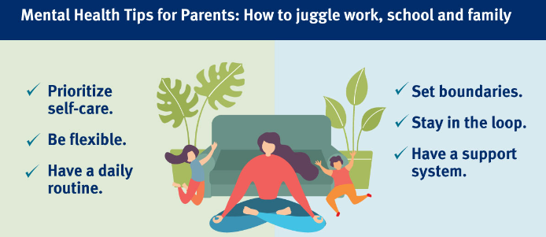
If you want some walks or outdoor activities to do this spring, check out what’s happening in our local parks. Many are free.
https://www.theparkstrust.com/whats-on-in-your-parks
The MK Mental Health Support Team
The Milton Keynes Mental Health Support Team have two upcoming parent groups. The first is ‘Helping Your child with Fears and Worries’. This is a parent-led, guided self-help intervention which aims to provide parents with an increased understanding of anxiety and how it is maintained. It will help you identify triggers and support you with practical strategies to help your child. The next group starts in the Summer Term.

The second is ‘Reframe: Behaviour as Communication’ and is a group aimed at reducing parent-child conflicts through the promotion of family relationships and parenting approaches. The next group starts on April 18th, 1.00-2.30pm on Zoom.

Both groups are aimed at parents of primary age children. If you feel that either group would be suitable for you, please speak to your child’s teacher who will complete a referral to the MHST if your school is working with them.

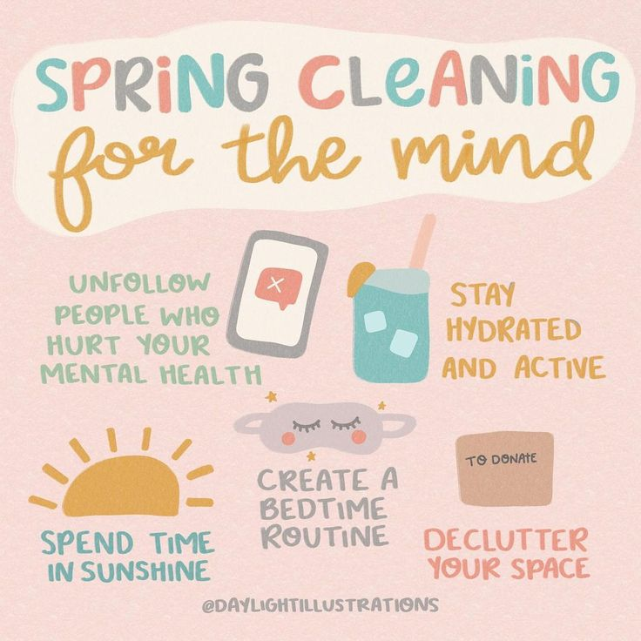
Welcome to our Spring Term ILF Wellbeing Newsletter.
As we start to say goodbye to winter and spring emerges, many of us spring clean our mental health as well as our homes. The increased sunlight exposure can boost serotonin levels in the brain, acting as a natural antidepressant for many. This “lift” in mood is a tangible and welcome transition for those battling winter-induced SAD. We can use the arrival of spring to not only boost our mood but also connect with the outdoors and others which is good for our mental health and wellbeing. Click on the links to find more detailed tips and ideas to boost your mental health this spring.

https://mentalhealth-uk.org/blog/how-we-can-use-spring-to-boost-our-mental-health/

https://www.benenden.co.uk/be-healthy/mind/nine-ways-to-spring-clean-your-mind-and-body/

Key Dates
11th-17th March Nutrition and Hydration Week
15th March World Sleep Day
1st-30th April Stress Awareness Month
7th April World Health Day
1st-31st May National Walking Month
13th-19th May Mental Health Awareness Week

