Why do bees have sticky hair?
They use honeycombs.
We wish everybody a happy and safe summer holiday. Make sure to eat healthily, get outdoors and be kind. Good luck to all the Year 6 children starting their secondary schools.
From the Wellbeing Ambassador Team:
Sophie-Ann, Lily, Otis, Archie, Ashlynn, Kavya, Frankie and Clayson.

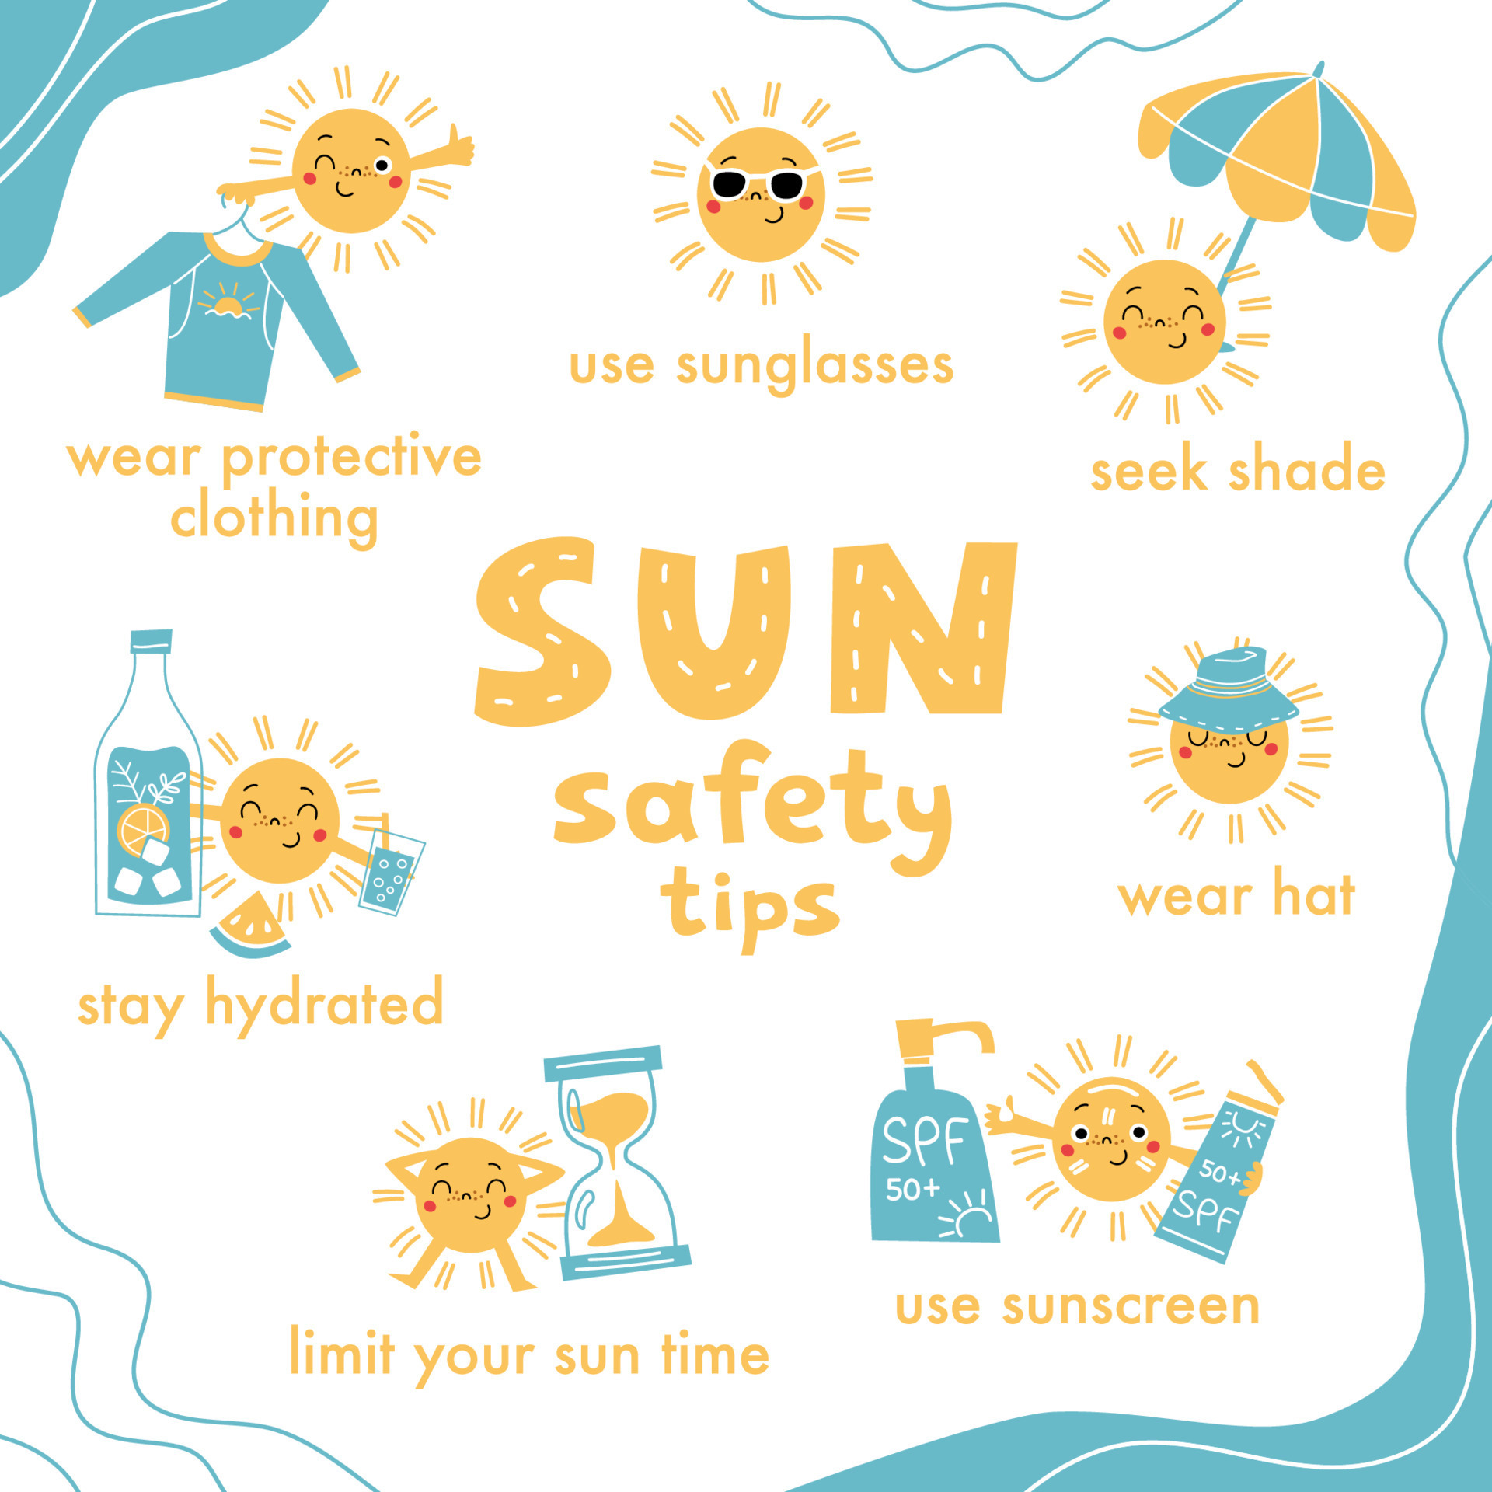
Spot the Difference
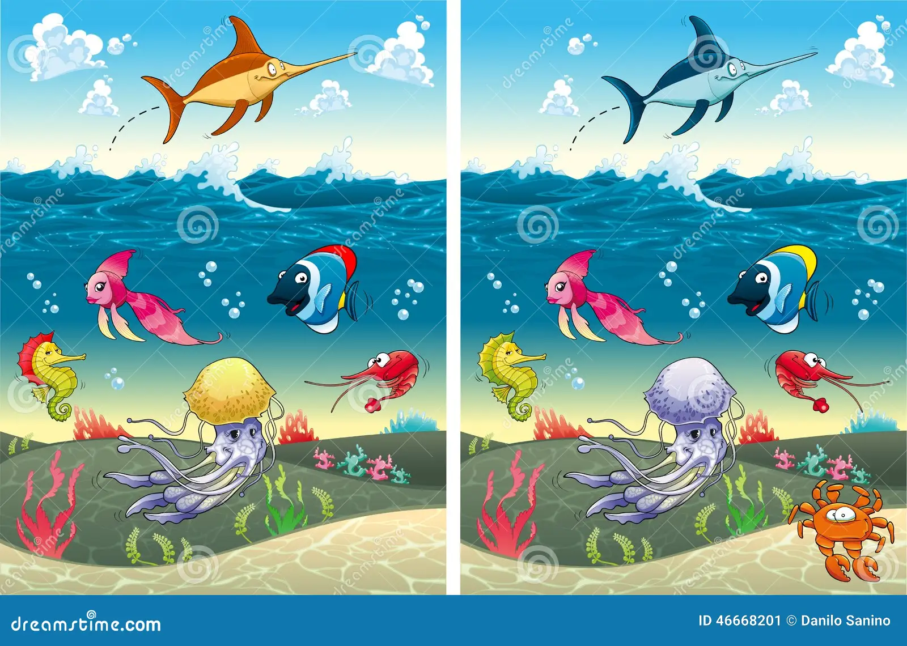
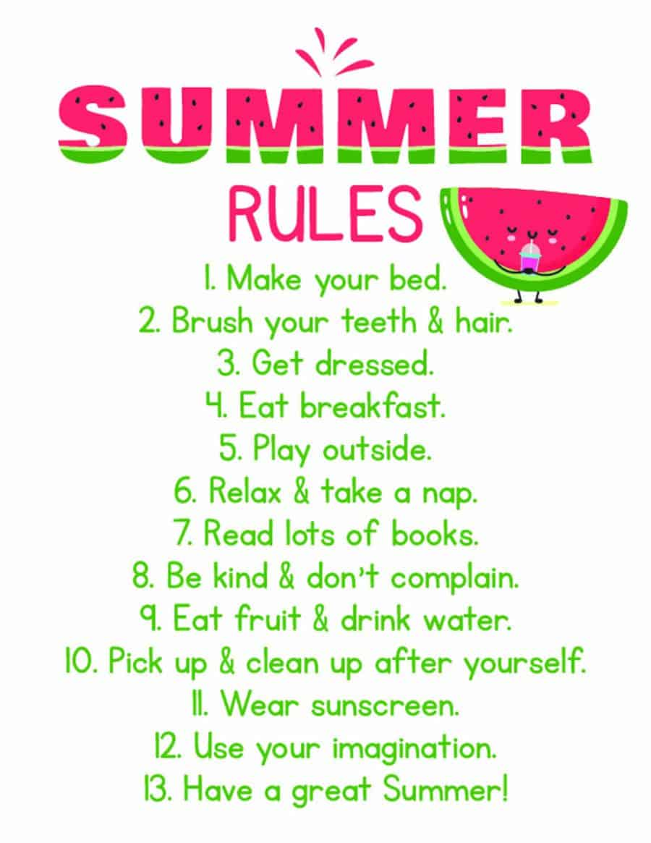
Activities to help your wellbeing
This website has lots of ideas of practical ideas you can do.
https://www.nightzookeeper.com/blog/articles/fun-creative-activities-for-childrens-wellbeing

Build your Happy Place is a game which helps you feel calm, safe and happy. https://www.childline.org.uk/toolbox/games/#filter

Here’s a game to give you some wellbeing tips and for you to write down your feelings privately.
https://scratch.mit.edu/projects/1028977372/
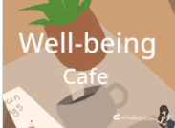

Welcome to the latest edition of the BVS Wellbeing Newsletter.

This newsletter was brought to you by the Bradwell Village School Wellbeing Ambassador Group. June 2024.
Keep me or recycle me.
BVS Wellbeing News

