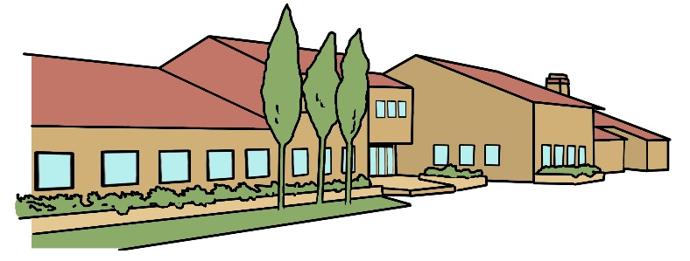
Bradwell Village School
Year Three Newsletter
September 2024

Subject Overviews
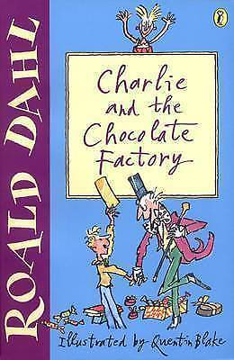
English
We will be working on descriptive writing, particularly focusing on settings and character descriptions using the rainforest and Charlie and the Chocolate Factory for some of our inspiration. As part of our English lessons we will play lots of word games to help develop our spellings and we will consolidate and practise sentence punctuation. We will also be learning how to make our writing more interesting through the use of adjectives and adverbs.

Maths

In Maths we will develop written methods for addition and subtraction and know how to use these methods to solve word problems. We will also be focusing on the children’s understanding of place value and the relationships between numbers and number facts. We will use our Back to Basics sessions to develop rapid mental recall of sequences of numbers, number bonds and times tables. Each week we will either have a problem-solving lesson, where we will learn and practise a range of strategies to solve logic problems, or we will consolidate our written methods. We will also develop our arithmetic skills through our Back to Basics sessions.

Science
Through our learning about the rainforest we will be finding out about the life cycles of plants and what they need in order to live and grow, as well the different parts of flowering plants. We will also find out about how things are seen and learn about reflections, as well as finding out about sunlight and shadows.

Computing
We will be learning about e-safety and what steps we can take to stay safe online. We will be looking at what potential dangers the internet can have and how to avoid them in order to keep safe. We will then look at programming and how to use a programming language to program an animation.
Games/PE
In Games & PE we will learn different skills to help play a range of invasion games. We will also develop the skills used in gymnastics to make, perform and evaluate our own routines and sequences.

Music
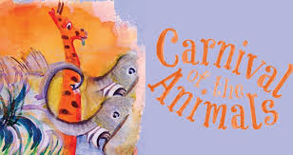
In Music we will be learning about different musical styles and what instruments can be used to create these. We will then be learning basic instrumental skills by listening to and playing tunes in different styles.

RE/PSHE
In RE we will be learning about Christianity and Judaism. In PSHE we will be learning about new beginnings and how to get on with others. We will participate in Circle Time activities and discussions. We will also be promoting the values of Kindness & Respect.

In History we will find out who first discovered chocolate and brought it to Europe. We will also find out why cocoa beans were so important for trade.

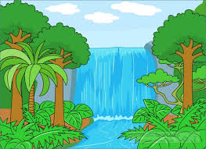
In Geography we will find out where cacao trees are found, and about different products from the rainforest. We will use maps and atlases to locate rainforests and learn about the positions of longitude and latitude, the Equator and the Tropics. We will also find out why rainforests are being destroyed and how people are trying to save them. We will look at some of the main features of North and South America and compare different regions within Brazil, as well as finding out about how rainforest tribes live.
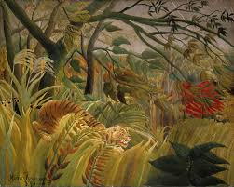

In Art we will look at the paintings and techniques of Henri Rousseau. We will consider how art can be used to create a rainforest scene and make our own. We will learn different sketching techniques and sketch trees.

In Design & Technology we will learn how to make chocolate and what can be added to change its flavour. We will design and make a wrapper for a new chocolate bar.

Homework:
The children are set homework each week which we require them to complete. We ask that the children are encouraged to do their very best with their homework with written work completed in pen and maths work completed in pencil. In preparation for the test on Friday, please encourage your children to practice their spellings on the Spelling Shed website and times tables on TT Rock Stars.

Year 3 Teaching Staff
Miss Branch and Mrs Hodges (Class Teachers 3BH) and Mrs Noor (Class Teacher 3LN).
You can contact your child’s class teacher via class emails.
Learning Support Assistants: Mrs Robinson and Miss Allan

We look forward to a wonderful term of hard work, challenge and celebrating success.
The Year Three team.

