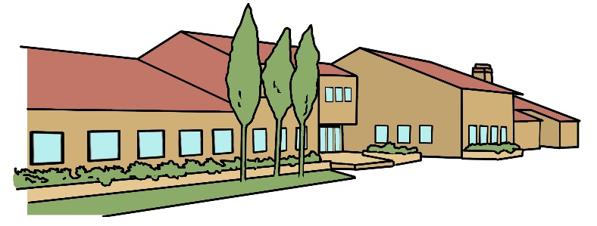
Bradwell Village School
Year 4 Newsletter
September 2024

Subject Overviews
English
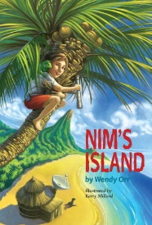
During this term, we immerse ourselves in two books, which relate to other curriculum areas and allow the children to explore different styles of writing relating to volcanoes and fire. The first is Nim’s Island from which they will write a diary entry and a letter. The second text is The Firework Maker’s Daughter. We use this text to stimulate story writing and description. We will continue practising spelling, punctuation and grammar throughout the week and any practise at home will be helpful in developing these skills.

Mathematics

To begin with, maths in Year 4 will focus on number skills and increasing the size of the numbers the children use to calculate with. They will be learning more advanced methods for the four operations which they will use throughout the year. We will begin practising our times tables as these are vital to all areas of maths and give the children a great head start. This will also help to prepare the children for their MTC test in the Summer Term.

Science

In studying sound this term the children will learn how sound travels and what affects volume and pitch. In addition, we look at solids, liquids and gases and devise an experiment to test them.

Computing
After learning how to stay safe online, the first term of Year 4 focuses on refreshing the basic computing skills and giving the children confidence to explore computing programs. They will then delve back into coding to learn how to program a moving object.
Games/PE
In Games the children will be looking at techniques to help them with invasion games and hockey in particular. During PE the children will be going swimming – please ensure you complete the online medical form before September.
Music

The children will explore how to record different sounds and, using their recordings, they will note down their own melody. They will then have the chance to play this on a range of instruments.

French
French in Year 4 involves the children learning how to use words relating to the weather, travel and sports. They will learn these through vocabulary pictures, paired work and song. The children will also be taught how to use a bi-lingual dictionary.

RE/PSHE
During our RE lessons, the children will have the opportunity to learn about Santana Dharma and think about the significance of the Nativity Story. In PSHE we will start with the unit Being Me in My World where the children will think about their roles and responsibilities within school and their community.


In History we will be looking at the explosion of Pompeii and placing the events of history in chronological order.
In Geography we will be learning about what the Earth is made of and how it is formed. With this understanding, we will explore how volcanoes are formed and where they are located.
Our Art this term will concentrate on different painting techniques.
The Design and Technology this term provides the chance for the children to learn about pneumatics. Over the Summer, please collect spare boxes, newspapers and bottles that the children can use to make their own pneumatic volcano.


Homework
The children are set homework each week which we require them to complete. We ask that the children are encouraged to do their very best with their homework with written work completed in pen and maths work completed in pencil. In preparation for the test on Friday, please encourage your children to practice their spellings on the Spelling Shed website and times tables on TT Rock Stars. Homework will be sent home on a Friday and will be expected back in school on Wednesdays.

Reading
It is beneficial for the children to read daily from a range of texts and have the opportunity to discuss them at school and at home. In our guided reading lessons, we will be focusing on skimming, scanning and retrieval of information. Please ensure your child is accessing Myon at home and completing quizzes online.

Year 4 Teaching Staff
Mrs Heather Brodie-Shaw (Class Teacher)
Learning Support Assistants are Mrs Slaven and Mrs Bardsley

