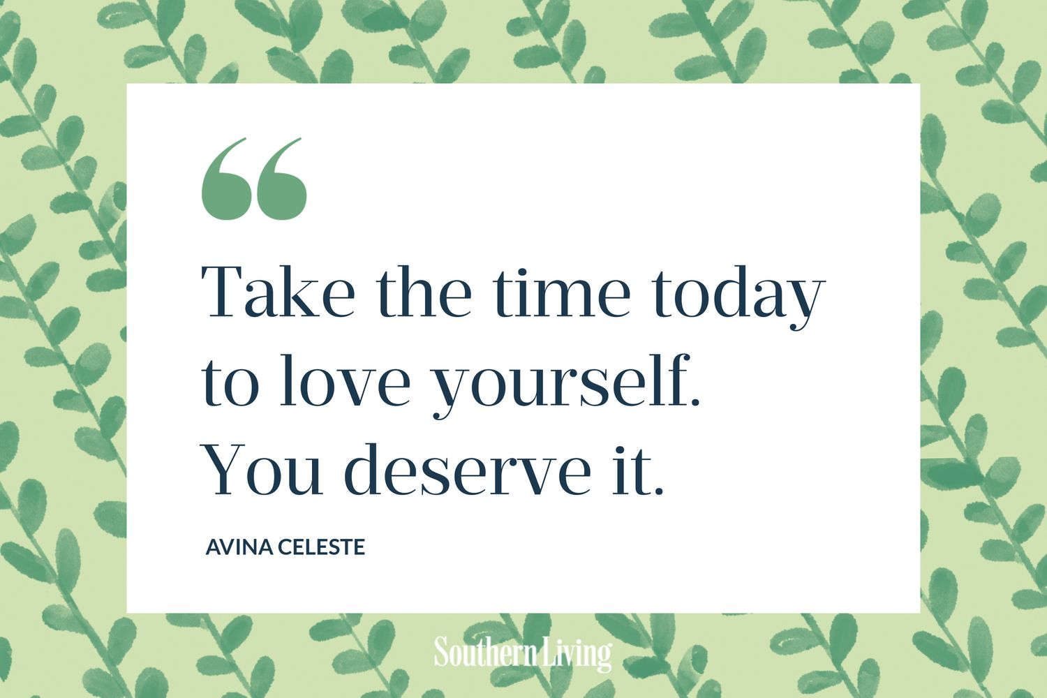
Click on the link to see all the places where kids can eat for free this summer holidays.
https://www.theparentsocial.com/kids-eat-free-during-summer-holidays-2024/
The Grumpy Cook at Loughton provides free meals for those in need. Find out more at https://table88.co.uk/


https://www.theparkstrust.com/outdoor-learning/holiday-activities/

Useful Links if you need any support over the Summer Holidays.
https://www.childline.org.uk/info-advice/home-families/seasonal-events/summer-holidays/

https://www.mind.org.uk/

https://www.samaritans.org/how-we-can-help/contact-samaritan/

https://www.arthurellismhs.com/

For housing advice, emergency accommodation, family support and mediation in Milton Keynes:
https://www.depaul.org.uk/get-help-in-milton-keynes/

For Safeguarding concerns contact:
Milton Keynes Multi Agency Safeguarding Hub (MASH)
Call 01908 253169 or 253170.
Email children@milton-keynes.gov.uk

Key Dates
July Samaritans Talk to Us month
24th July International Self Care Day
10th September World Suicide Prevention Day

Welcome to our Summer Term ILF Wellbeing Newsletter.
Although the children may be excited for six-weeks out of school, we appreciate that as parents and carers you may feel quite the opposite. We realise how difficult it can be to juggle childcare with work commitments.
- 1/3 of parents say the school holidays leave them feeling stressed.
- 47% of parents worry about thinking of things to do with children.
- 1/4 of parents say they feel exhausted.
- 52% of parents say the cost of taking children out for activities causes them the most stress during the holidays.
Click the link to find out ways of looking after yourself during the holidays.
https://www.bbc.co.uk/bitesize/articles/zx64r2p


