Welcome to our Autumn Term ILF Wellbeing Newsletter.
It's no surprise that Christmas can impact our mental health: normal routines are disrupted, and family relationships – or lack of – are thrown into sharp focus. There's an increased pressure to be out socialising, which can be draining – particularly at a time of year when there's less daylight and our natural instinct is to "hibernate" and be less active.

And that's before the pressures and build-up often associated with Christmas day itself – shopping, gift-giving, cooking, decorating... the list is endless. So how to make sure you navigate the festive season with your wellbeing intact?
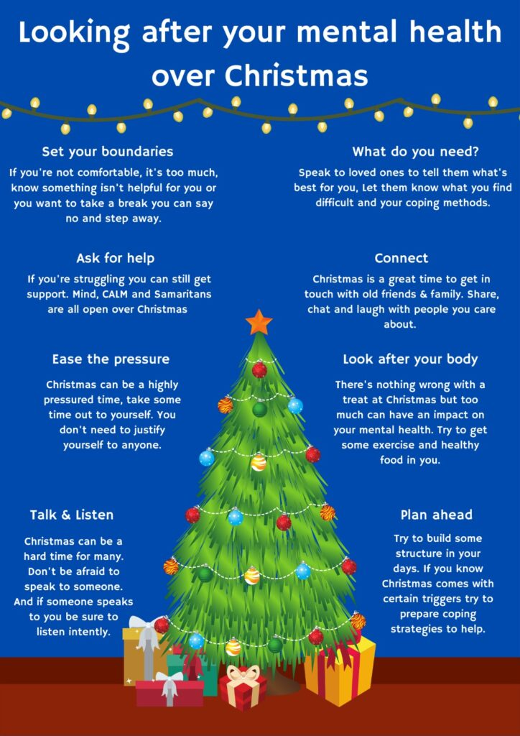
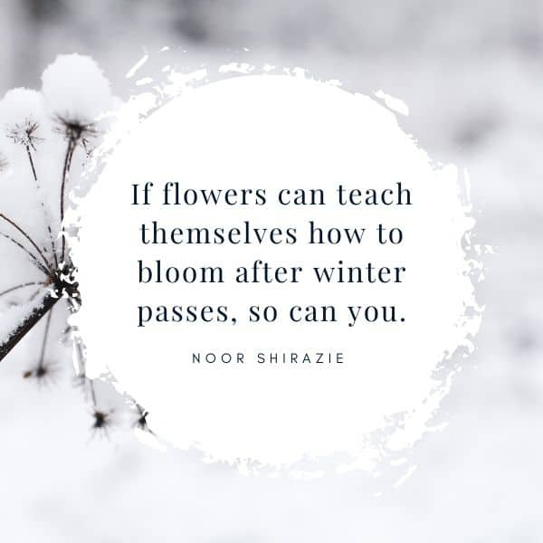
Meditation has been shown to help people stress less, focus more and even sleep better. Try these apps to help you achieve this. https://www.headspace.com/headspace-meditation-app
https://www.calm.com/

If you’re looking for something cheap or free to do this holiday, click the link. https://www.milton-keynes.gov.uk/leisure-sport-and-community-activity/free-and-low-cost-arts-and-heritage-all-enjoy
For more ideas, click below.
https://christmas-events-near-me.com/milton-keynes-england/
Milton Keynes City Council is funding a programme of FREE activity sessions and meals to give extra support to local families during the Christmas school holidays. The activity sessions are exclusively available to children, young people, and their families in receipt of benefit related Free School Meals. Find details of local support and advice at www.milton-keynes.gov.uk/cost-living-support
Useful Links if you need any support over the break.
https://www.mind.org.uk/information-support/tips-for-everyday-living/christmas-and-mental-health/christmas-coping-tips/

https://www.samaritans.org/how-we-can-help/contact-samaritan/

https://www.milton-keynes.gov.uk/health-and-wellbeing/mental-health-and-wellbeing

For Safeguarding concerns contact:
Milton Keynes Multi Agency Safeguarding Hub (MASH)
Call 01908 253169 or 253170.
Email children@milton-keynes.gov.uk

