
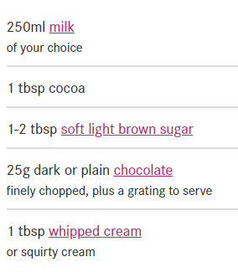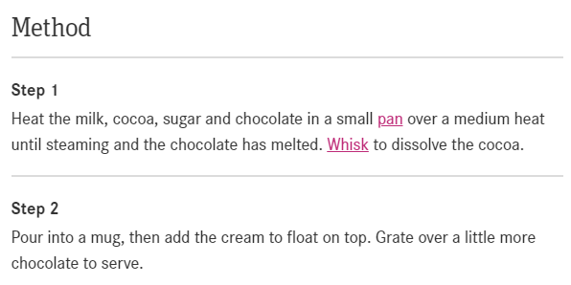
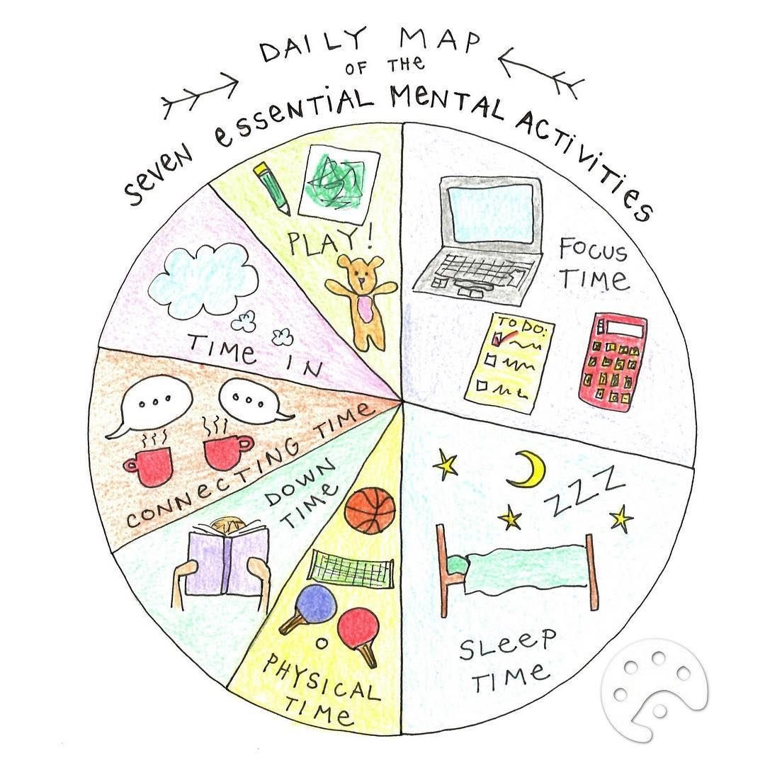
How to look after your wellbeing this holiday.
- Spend time with friends and family
- Less screen time
- Read a book
- Be active
- Get outside
- Treat yourself
- Be grateful
- Be calm
- Hug your pets



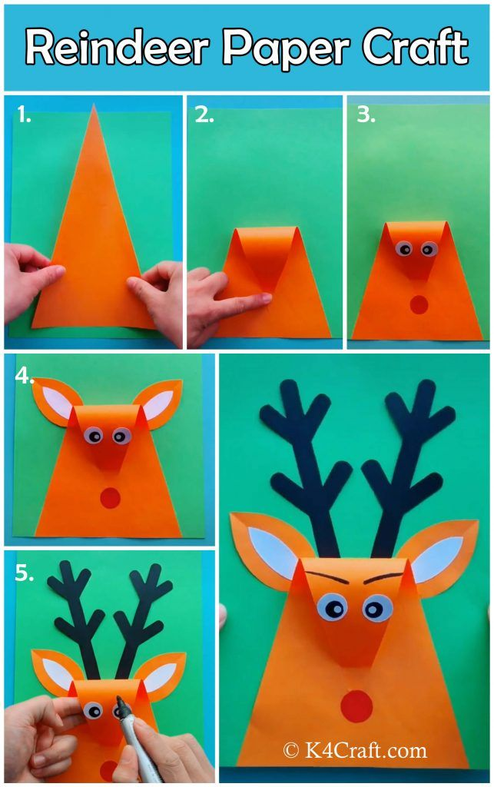
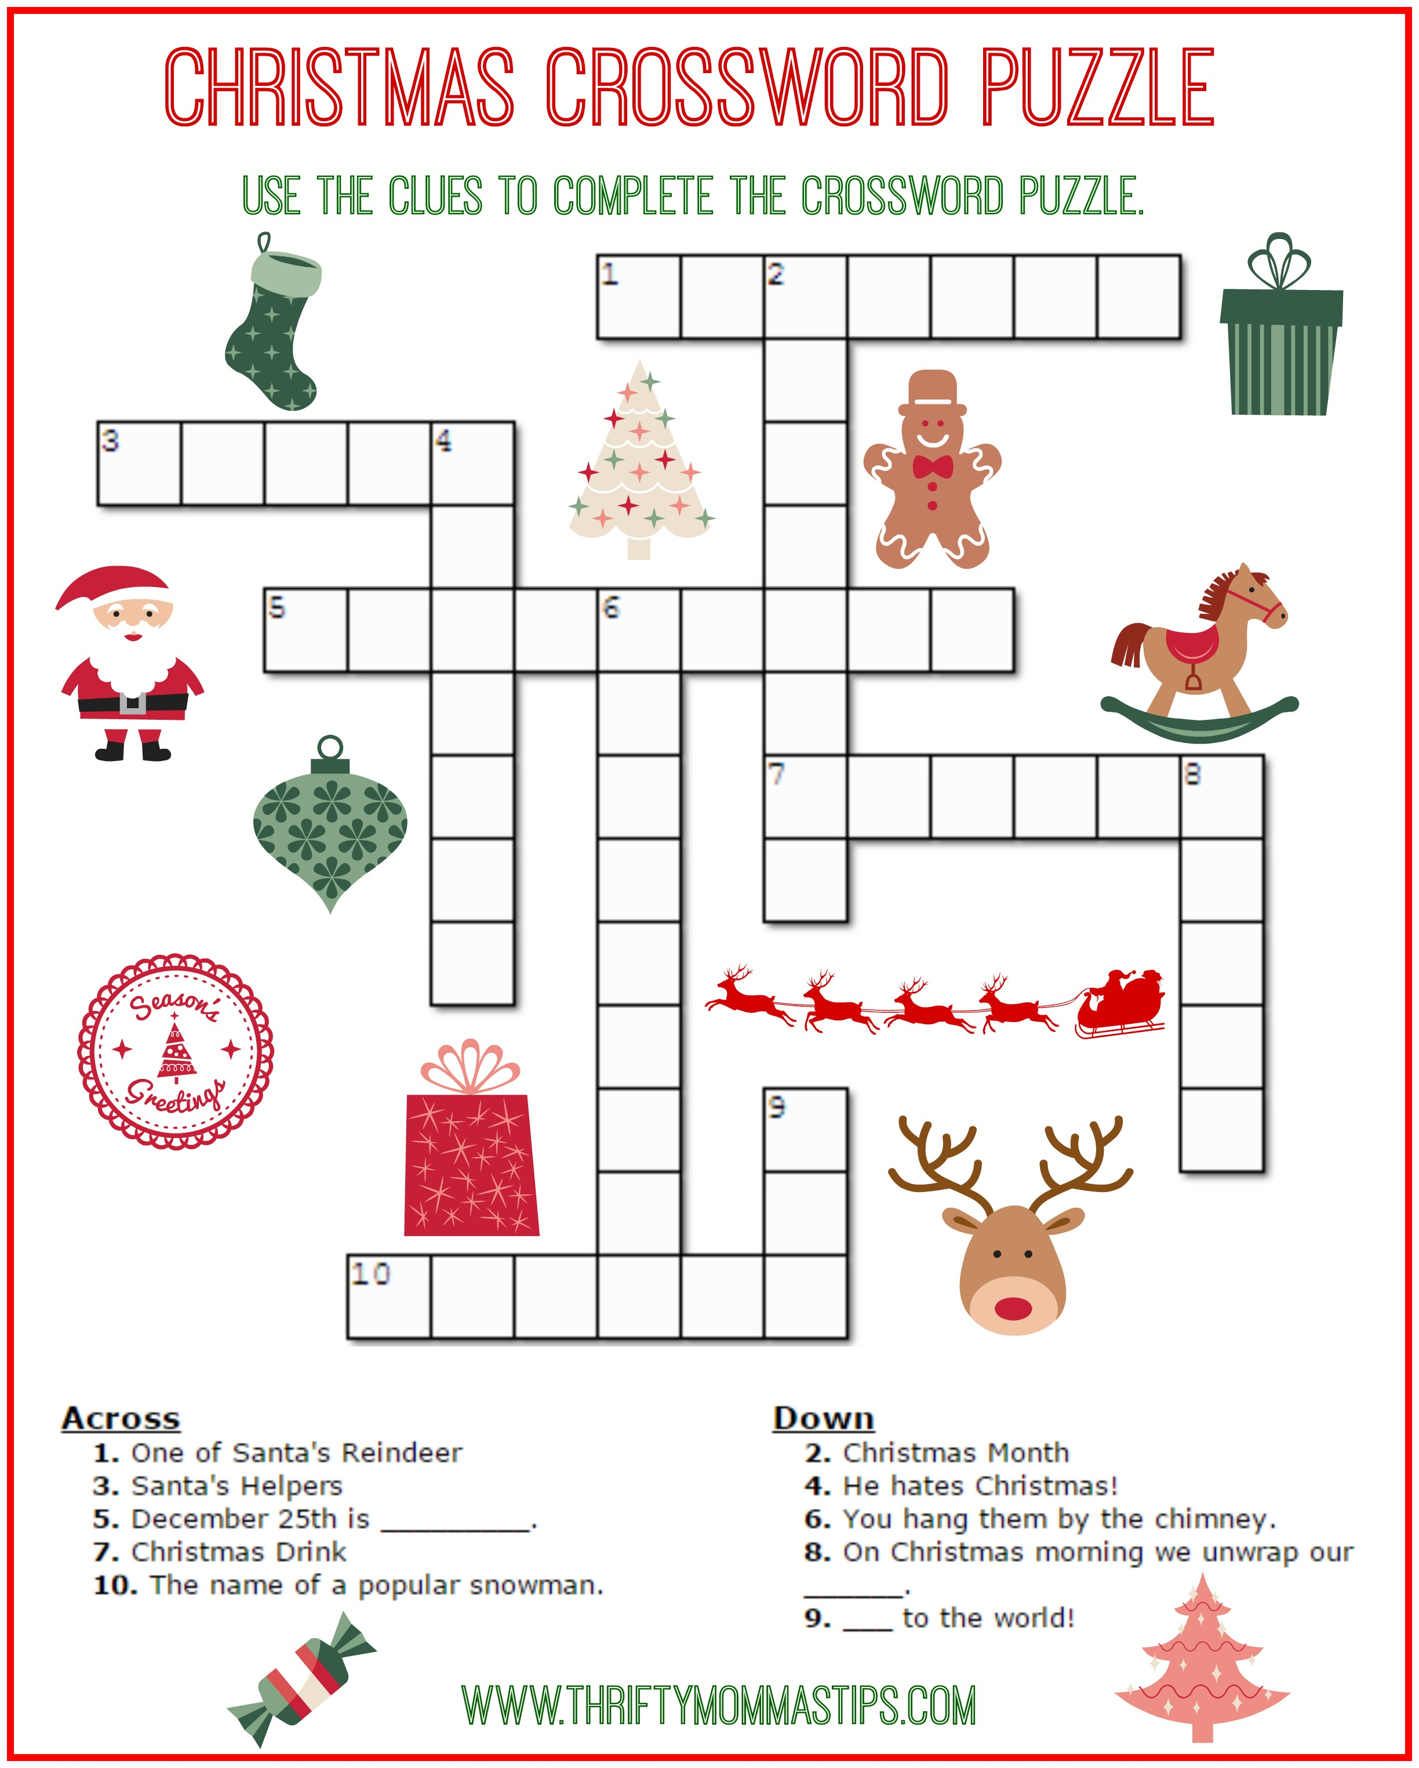
What do you call a polar bear that has headphones on?
Anything you like, he can’t hear you.
This newsletter was brought to you by the Bradwell Village School Wellbeing Ambassador Group. December 2024
Keep me or recycle me.
BVS Wellbeing News

