Tuesday 25th March

Dear parents/guardians,

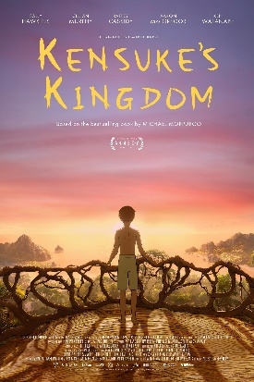
To round off our Guided Reading lessons where we have been studying the book ‘Kensuke’s Kingdom’, we would like to watch the movie. This movie is certificate rated PG, so we ask you to confirm that you give permission for your child to watch this on Thursday 3rd April by signing and returning the slip below no later than Wednesday 2nd April.

Thank you in advance.

Year 5 Team

I give permission

I do not give permission

for _____________________________(name) in _____________ (class) to watch Kensuke’s Kingdom.

Signature__________________________________ Date_______________________

