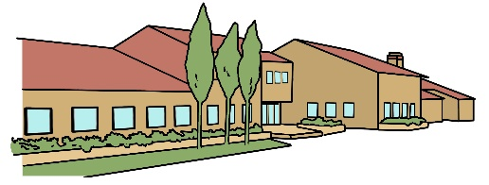


Bradwell Village School
Walgrave Drive
Milton Keynes
Mk13 9AZ
admin@bvs.ilf.education

3rd April 2025

Safeguarding - emojis

Dear Parents / Carers,

I hope this message finds you well. I am reaching out to share some important information regarding our ongoing commitment to safeguarding our pupils, particularly in relation to digital communication.

You may have recently watched or heard about the series Adolescents, which has recently come out on Netflix. This programme delves into the meanings behind various emojis that are commonly used in messaging among young people today. As part of our efforts to support you and your child in navigating these conversations, I have attached a selection of the emojis discussed in the series.

Understanding the nuances of these symbols can be crucial, as they often convey emotions or messages that may not be immediately clear. Here are some key points to consider:

- Communication Awareness: Familiarising yourself with the meanings of these emojis can help foster open discussions with your child about their online interactions.
- Encouraging Dialogue: Engaging in conversations about digital communication can strengthen your relationship with your child and provide them with a sense of security.
- Safeguarding Practises: By being aware of the emojis your child uses, you can better understand their feelings and the context of their messages.

I encourage you to take a moment to review the images over the page and consider how these emojis may be relevant to your child's / children’s communication. Should you have any questions or wish to discuss this further, please do not hesitate to reach out.

Thank you for your continued support in keeping our pupils safe and informed.

Warm regards,

Lisa Vincent

Head of School



