Thursday 5th June 2025
Dear Parents/Carers,

We are pleased to inform you that we have arranged for Bikeability training to take place at BVS on Wednesday 16th, Thursday 17th and Friday 18th July 2025. These sessions will take place during the school day.

The scheme is run and managed by the Milton Keynes Council and the instructors are employed by the Council to deliver combined Level 1 and 2 Bikeability training.

Level 1-( approximately 1 - 1.5 hours) a playground-based session which enables the trainers to evaluate the children prior to progressing to Level 2.
Level 2 (approximately 6 hours in total) which is then undertaken on the local roads and Redways in the school’s vicinity and is aimed at enhancing skills and building confidence in areas where the children would normally ride.

The training is delivered over three half days to a total of 24 pupils and is taught at a ratio of 1 instructor to 12 pupils. We intially have 24 places, however if more than 24 places are required, we will liaise with Milton Keynes Council to request additional instructors. BVS will be paying for the training as part of our Sports Funding so there is no charge to our families.

Please note, all pupils must be able to ride a bike before attending the course. If you or your child cannot ride a bike and would like to learn, contact the Council’s Cycling Team.

Equipment – pupils should arrive at the training session with appropriate clothing. In wet weather this should include a waterproof and in warm weather, sun screen and water.

Pupils must bring a suitable bike that has been checked and is safe. The instructor will also check the bikes. If a bike is deemed unsafe then the pupil may not be able to participate. Principle areas to check on the bike are:

- Tyres, must not be too worn and the underlying thread must not be visible
- All bikes must have 2 working brakes
- Brakes must stop the bike well and pupil must be able to operate them
- Gears must be operative
- The bike should fit the pupil

The pupils must have a helmet that fits and is not damaged. If the pupil arrives without a helmet or if the helmet is deemed unsafe by the instructor, the pupil may not be able to participate. Full face helmets or helmets covering the ears are not permitted.

Please fill in the attached form and return it to Miss Rudkin in Year 6, by Friday 20th June 2025 if you would like your child to take part.

Parents/ Carers consent form

Please read the following information before completing and returning the consent slip.
I understand that:

- I agree to my son/daughter taking part in cycle training
- The instructors may refuse to train my child if they deem his/her cycle to be unroadworthy
- My son/daughter can already ride (they may be refused if not able to do so)
- It remains my responsibility to ensure my child does not ride an unroadworthy bike and if I am in doubt as to whether a cycle is roadworthy, I should seek advice of a professional mechanic
- Instructors may at any time refuse to continue to train my child if his/her behaviour or cycling ability is deemed unsuitable
- Milton Keynes Council will not be responsible for any injury or disease transmission or liable for any loss or damage to participant’s cycles and other belongings
- I agree for my child to wear a helmet, which I will provide
- I consent to the Bikeability instructor ‘adjusting’ my child’s helmet if required, however I confirm they are not responsible for the physical condition or appropriate fitting of the helmet
- I understand that pupil data collected will be used to support the delivery and monitoring of training sessions/courses, see bikeability.org.uk/privacy-statement/ for further details.
- I agree to encourage my child to practice between each session and after the completion of training.
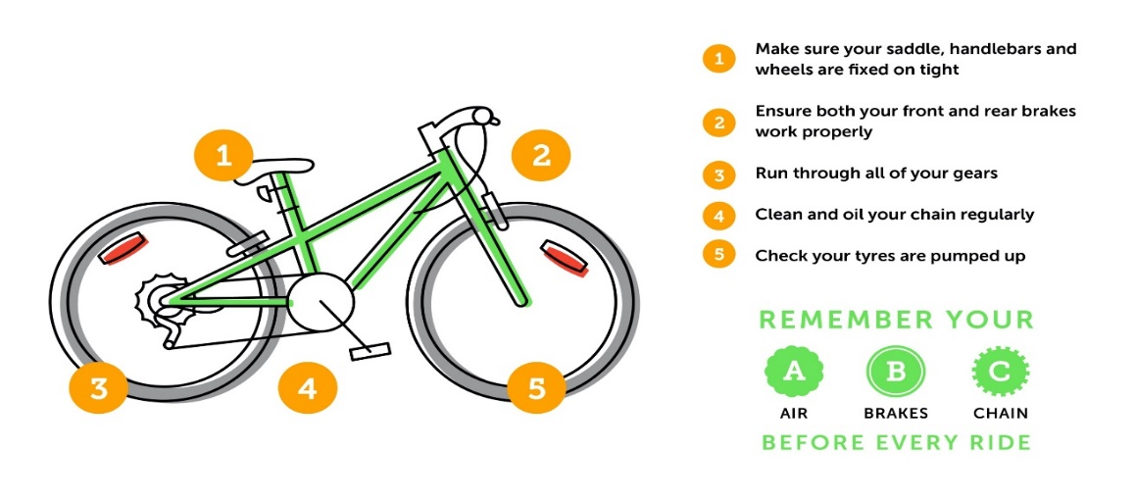

Child’s name:______________________________________ Class:____________________

To take part in the level 2 training your child MUST be able to do the following without stabilisers
- Look behind while pedalling in a straight line yes/ no
- Pedal one handed in a straight line (both hands) yes/no

Photography
If you are happy for your child to be photographed and/or filmed to help promote Bikeability by Milton Keynes Council, please tick here:

Signed:____________________________ parent/carer Date:_________________

