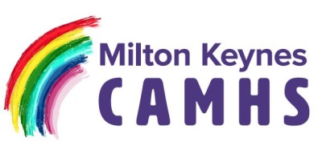
SLEEP HYGIENE
Ensuring we have a good night’s sleep can be a little trickier when there is a lot going on. Schools being closed and changes to routines for example, can create various emotions which can impact on sleep.
www.sleepfoundation.org have valuable information on how to address sleep hygiene issues.
Within this pack you will find a list of online resources which have a wealth of valuable information in addressing young people’s mental health difficulties.
In the interest of avoiding additional challenges to those you may already be facing, we would advise keeping the timings within your day as close to your usual routine day as possible, for example getting up and going to bed at your usual time. Paying attention to all areas of self-care is important and examples of this are given below.



SELF-CARE
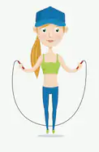
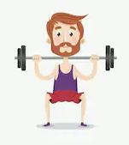
EXERCISE

With the government’s restrictions regarding social distancing, going out at the moment can be difficult apart from to exercise with an adult which shouldn’t really be an issue. Having to stay indoors could potentially lead to a lack of enthusiasm in things such as getting up and dressed.
It is important to help your child stay on top of their self-care as part of a regular routine such as taking a shower every day to make them feel fresh and motivated.
Active Mind – there are lots of activities to find for free on YouTube or Google for example crafts, learning sign language, tours of zoos and even the Egyptian Pyramids!
Daily exercise is a good idea for keeping serotonin levels up, there are lots of videos to find on You Tube and Google for free, Joe Wicks and Davina McCall for example are two who have given free access to their exercise at home content

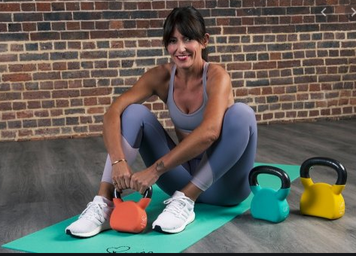


Notice your child’s mood and any changes to it. Include some time together each day, young people may automatically withdraw to their rooms. Try to ensure that they spend time with you so that you can talk together and you can guage how they are feeling.

If you feel that problems are escalating, perhaps with raised anxieties or a lowering in mood, you can try some of the ideas on the enclosed sheets. If used in a meaningful way they can make the brain too busy to focus on things that worry us or make us upset.
SUPPORT
DISTRACTION TECHNIQUES

You will find a list of distraction techniques; these are best practiced with your child when things are less challenging so that they are familiar to them when things are more challenging. They can then be used to prevent emotions from becoming too big and difficult. Essentially, the techniques make the brain too busy to continue producing the stress hormones.

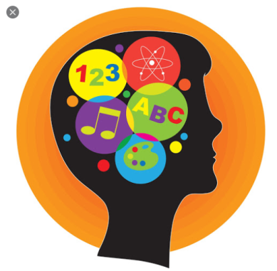
Active listening is essential – listening and trying not to automatically ‘fix’ or ‘rescue’ your child is a real parenting challenge. Having your child feel listened to and validated is very important, sometimes much more important than fixing their problem for them. Use phrases such as, ‘I understand how you are feeling’ if you agree with them, or ‘I never looked at it like that before’ if you are struggling to see things from their point of view, rather than disagree with them.

KEEPING YOURSELF WELL

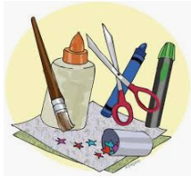
Anything which involves hand/eye co-ordination is an excellent distraction technique, so think about activities such as getting your young person to paint your nails, braiding hair, doing some colouring in, being creative with crafts, there are currently a huge number of activities online which have been made free to access, make Google your best friend and have a look!

Currently as parents and carers, there is a demand on us to be everything all at once, parent, teacher, entertainer, worker, provider, the stress can be overwhelming. It is so important that you take some time to care for yourself, be that taking a bath, listening to some music, using the distraction techniques for yourself, getting good sleep and meals in.



Use the online resources for support and ideas and contact us should there be urgent situations you feel you are unable to manage.

In order to provide consistent support across all areas of our service, we have a dedicated duty team ready to answer any urgent calls. In the instance of any mental health emergencies please contact us first on 01908 724544, Monday to Friday 9am – 5pm.

We sadly know that some of our young people resort to causing deliberate self-harm at times of stress. This does not apply to all young people and we are not mentioning this in order to frighten you, we feel providing information is key, to support you in keeping your young people safe.
As a parent or carer, the most important way to react on discovering any deliberate self-harm on your child, is to remain calm. We do know this is challenging for you.

SAFETY
Whilst A&E does remain open for emergencies where medical intervention is required, we are requesting that young people and families only attend if there is a significant medical need to be in A&E. We do have staff available to offer urgent face to face appointments within Milton Keynes Specialist CAMHS under social distancing rules during normal working hours. By contacting us on the above number we can arrange this where appropriate. This system allows us to minimise any risk to yourselves during the pandemic.

Removing access to anything that can be used to cause self–harm puts a significant and important obstacle in the way of opportunity. Look for sharps, medications and any other harmful substances or items and remove and secure them to a safe place.
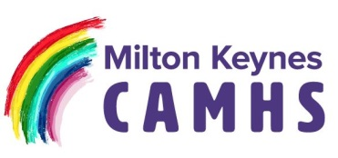

If your young person experiences suicidal thoughts, be calm and patient and offer the opportunity to support them. Use the distraction techniques and ensure someone is with your child.
The number to call for any urgent situation that does not require immediate medical attention;

CAMHS Duty Line
Monday to Friday 9am – 5pm
01908 724544

Call 111 for a physical medical emergency

