Covid-19 / Coronavirus Resources

Government Website
https://www.gov.uk/government/publications/covid-19-guidance-on-supporting-children-and-young-peoples-mental-health-and-wellbeing/guidance-for-parents-and-carers-on-supporting-children-and-young-peoples-mental-health-and-wellbeing-during-the-coronavirus-covid-19-outbreak

BPS Guidance
https://www.bps.org.uk/news-and-policy/talking-children-about-coronavirus

BACP Guidance around Managing Anxiety
https://www.bacp.co.uk/news/news-from-bacp/2020/28-february-coronavirus-anxiety-how-to-cope-if-you-re-feeling-anxious-about-the-outbreak/

Anna Freud Links
Supporting schools & colleges: A guide to supporting the mental health and wellbeing of pupils and students during periods of disruption There are also three videos, one for school staff, one for parents and one for children and young people which may be useful.
https://www.annafreud.org/what-we-do/anna-freud-learning-network/coronavirus/

Liverpool CAMHS Resource
https://wakelet.com/wake/564d7bc8-4bc9-462f-a9e1-2deb03150c3

National Autistic Society
The National Autistic Society (NAS), a national charity for people with autism and their families, has a useful section on their which offers handy tips for parents during this time of uncertainty https://www.autism.org.uk/services/helplines/coronavirus/resources/tips.aspx

Website: www.autism.org.uk
Helpline: 0808 800 4104
Due to the impact of the COVID-19 virus, Helpline telephone lines will be amended to Monday to Friday 10.00am – 3.00pm
On line enquiry forms: https://www.autism.org.uk/enquiry

Mencap - Easy Read guide to Coronavirus
https://www.mencap.org.uk/sites/default/files/2020-03/Information%20about%20Coronavirus%20ER%20SS2.pdf

Place2Be
Guide to helping parents answer questions from their children and to support family wellbeing: https://www.place2be.org.uk/about-us/news-and-blogs/2020/march/coronavirus-information-for-children/

Young Minds
Young Minds provides a helpline of support and advice to anyone worried about their own mental health and well-being, or are worried about someone else. This charity also offers a free helpline for parents.
https://youngminds.org.uk/blog/talking-to-your-child-about-coronavirus/

Tel: 0808 802 5544 (Parent’s helpline open Monday to Friday 9.30am – 4pm)
Website: https://youngminds.org.uk/ - this website also offers a free 24/7 text message crisis line, if you need urgent help text YM to 85258.

Carers UK – Guidance for Carers
https://www.carersuk.org/help-and-advice/health/looking-after-your-health/coronavirus-covid-19

Covibook
An interactive resource designed to support and reassure children aged 7 and under, designed to help children explain and draw the emotions that they might be experiencing during the pandemic: https://www.mindheart.co/descargables

Amaze
Information pack for parents: https://amazesussex.org.uk/faqs-about-the-coronavirus-for-parent-carers-of-children-with-send-brighton-hove/

Public Health England have produced an easy read version of their Advice on the coronavirus for places of education. You can download it here: https://www.publichealth.hscni.net/sites/default/files/2020-03/V4%20Coronavirus%20advice%20for%20schools%20poster%20020302%20EDU15.0.4%20%282%29.pdf

The Mix
The Mix provides free and confidential support to young people about a variety of different issues they may be facing, such money worries, homelessness, finding a job, a break-up and how to cope with the changes of life due to Covid-19.

Tel: 0808 808 4994 (phone lines are open 4pm to 11pm every day)
Website: https://www.themix.org.uk/ - the website also offers a 1-2-1 chat room and a crisis text message service which provides support 24 hours a day, 7 days a week. If you’re aged 25 or under, and are experiencing any painful emotion or are in crisis, you can text THEMIX to 85258.

Kooth
Kooth is an online counselling and emotional well-being platform for local children and young people between the ages of 11 and 19. Kooth is accessible through mobile, tablet and desktop and offers free safe and anonymous support for young people.
Website: www.kooth.com
Access online support
Monday – Friday 12pm – 10pm Saturday – Sunday 6pm – 10pm

YiS Young People’s Mental Health
YiS, a local service, offering free and confidential counselling to young people aged 11 – 21 years. Young people or adults that support them can contact YiS to get informal support and advice from one of their trained professionals.
Website: www.mkyis.org.uk
Chat with YiS on Messenger m.me/YiSMentalHealth

SHOUT
SHOUT provides free 24/7 confidential support via text for anyone in crisis and struggling to cope. You just need to text SHOUT to 85258 to be connected to a trained Crisis Volunteer. SHOUT volunteers will provide action listening and collaborative problem-solving.
Website: https://www.giveusashout.org/

ChildLine
Childline provides a confidential telephone counselling service for any child with a problem. ChildLine can offer advice and support about topics such as bullying, abuse and family life. ChildLine also offers an online chat option which means children and young people can speak to a counsellor if they prefer to not speak on the phone.

Tel: 0800 1111 – due to Covid-19 phone lines and the online chat are now open between 9am and midnight every day.
Website: https://www.childline.org.uk/

Samaritans
Samaritans provides telephone support and advice to anyone in need. They will listen to anything that is upsetting you including intrusive thoughts or difficult thoughts and self-harm.

Tel: 116 123 (free confidential line, open 24/7)
Website: https://www.samaritans.org/

Mind BLMK
Mind BLMK a national charity working with communities to support positive mental health. The well-being centre in Milton Keynes offers a range of services promoting positive mental health and well-being. From the 25th March 2020 the support will be offered remotely.

For those that need support with their mental health and would like to talk to someone

Website: https://www.mind-blmk.org.uk/how-we-can-help/milton-keynes/
Tel: 0300 330 0648
Email: hq@mind-blmk.org.uk

SANE
SANE provides emotional support, guidance and information to anyone affected by mental illness, including families, friends and carers. SANE is continuing to offer help through our team of professionals and trained volunteers.

Although their previous SANEline number cannot operate at the moment, you can leave a message on 07984 967 708 giving your first name and a contact number, and one of their professionals or senior volunteers will call you back as soon as practicable.

Website: http://www.sane.org.uk/what_we_do/support/
Email: support@sane.org.uk

Anxiety UK
Anxiety UK provides support for those living with anxiety and anxiety-based depression by providing information, support and understanding. Anxiety UK has extended their helpline hours to provide additional support due to the coronavirus pandemic.

Tel: 03444 775774 (phone lines are open between 9:30am to 10pm Monday to Friday and 10am to 8pm Saturday and Sunday).
Website: https://www.anxietyuk.org.uk/

MKAct
MK Act is a charity in Milton Keynes which works with families to help them move on from fear and abuse. The Government has categorised their services as essential and they are following the latest guidance and doing all their support over the phone unless they are unable to do so.

Their team of staff and volunteers continue to work and are covering all their phone numbers and email boxes which are listed below as normal so please phone/contact them between office hours of 9.00am-5.00pm.

Crisis Service Helpline – 0344 3754307 and info@mk-act.org
Professionals Helpline – 01908 295731 and info@mk-act.org
Refuge Service fst@mk-act.org and 01908 523720
Fresh Start – 07718767974 and freshstart@mk-act.org

Family Lives
The Family Lives website provides help and support for all aspects of family life. They are currently offering information, advice and resources on coping with family life during the Covid-19 outbreak. If you would prefer to talk to someone for support and advice, you can talk to a Family Support Worker on their confidential helpline.

Website: www.familylives.org.uk
Helpline: 0808 800 2222

Healthy Minds UK
Website: https://www.healthymindsmk.com/
Contact Number: 0741 5017325

Papyrius
Website: www.papyrus-uk.org/
Tel: 0800 068 4141

Children Commissioner
childrenscommissioner.gov.uk/coronavirus
On this website you can find Children’s Guide to Coronavirus and the Corona E-Book which can be downloaded. Another good resource is if you google the Coronavirus E-Book.

Service Six:
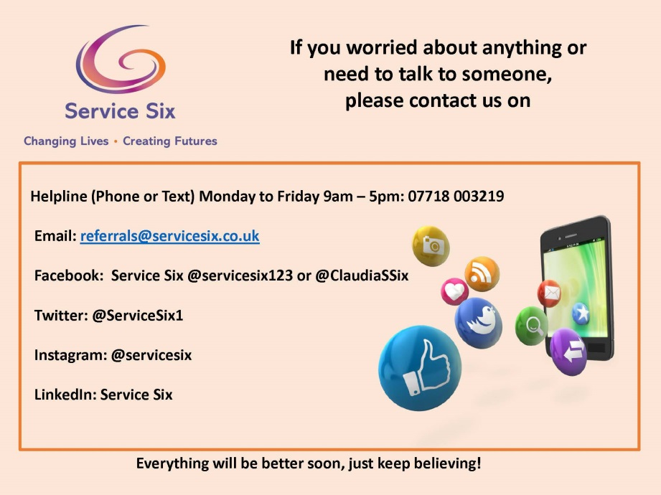

Action for Happiness
www.actionforhappiness.org can be used to look for different coping strategies.
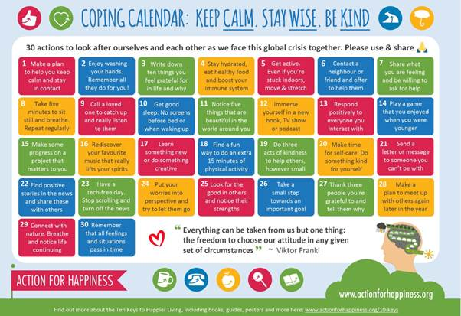

MK Talk for Change
Talk for Change offers access to talking therapies and mental health care

Website: https://talkforchange.org.uk/
Tel: 01908 725099
Email: support@talkforchange.org.uk

Adult Mental Health Crisis
If you or someone else needs urgent mental health crisis support you can call the
Urgent Care Team

Tel: 01908 724 365 or 111 or 999
For non-urgent mental health issues contact your GP

Covid-19 – Resources for Parents and Carers
https://www.rcpch.ac.uk/resources/covid-19-resources-parents-carers

Coronavirus Resources for LD/ADHD Community
https://eyetoeyenational.org/news/coronavirus-covid-19-resources-for-the-ld-adhd-community

Simple Strategies for Parents during Covid-19
https://www.psychologytoday.com/sg/blog/helping-kids-through-adhd/202004/simple-strategies-parents-during-covid-19

Coronavirus Help, 1-1
Have a Google and look for Dave the Dog worried about Coronavirus, a Nurse Dotty book

20+ free (or very cheap) ways to bring kids joy indoors
https://www.moneysavingexpert.com/team-blog/2020/04/free-or-cheap-ways-to-entertain-kids-indoors/?utm_source=MSE_Newsletter&utm_medium=email&utm_term=21-Apr-20-50603154-2071&utm_campaign=nt-restaurantdeals&utm-content=2#tiger

MK Council website will have information regarding financial hardship, food bank support etc. Please visit https://www.milton-keynes.gov.uk/

